6 Degree of freedom manipulator installation instructions

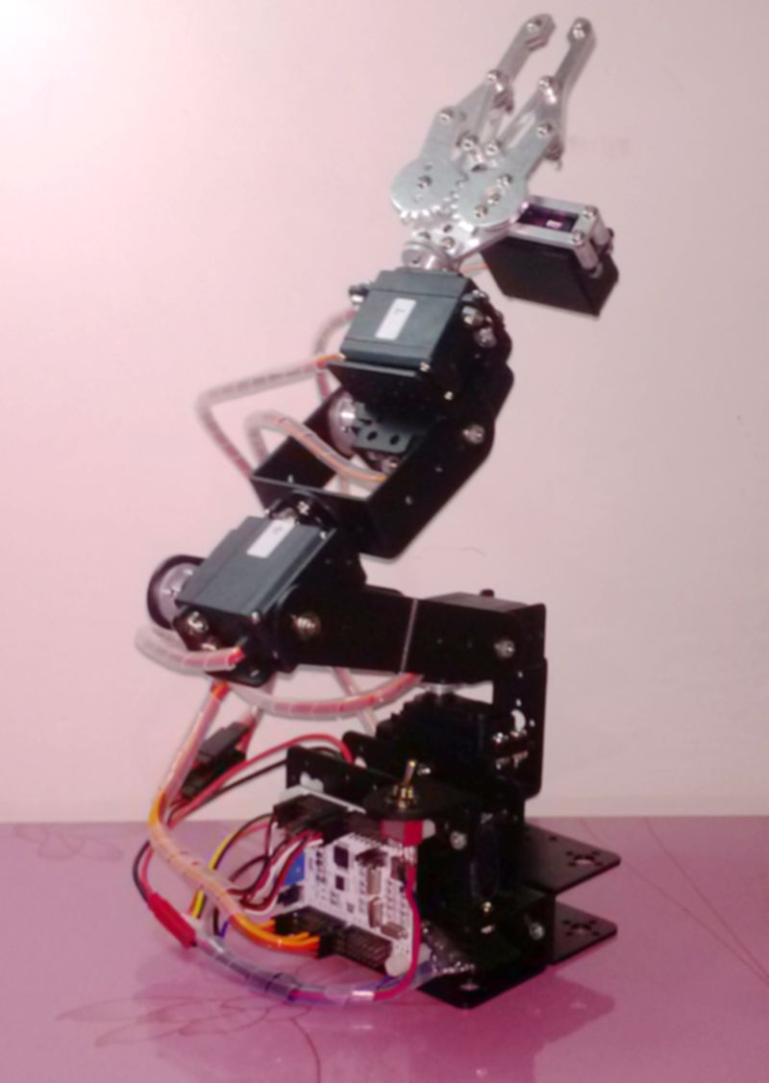

Copyright notice

Shenzhen Intelligent robot baby all rights reserved.

Shenzhen intelligent baby robots remain in cases without prior notice, modify the specifications of products and product specifications, such as the right to file.

Shenzhen smart-baby robot is improper use of this manual or the product, resulting from direct, indirect, incidental and consequential loss or liability.

Shenzhen Intelligent robot baby with this manual, as well as the property rights of the product described in this manual. Without authorization, shall not directly or indirectly copy, manufacture, processing, and related parts of this product.

First, machinery installation article
1, prepare a complete set of brackets and metal parts, are listed below:

Mechanical claws X 1
Arm steering gear bracket X 5
Arm long U -shaped bracket x 4
Robotic arm L -shaped bracket x 1
Robotic arm U -type Crossbeam x 3
Arm servo dedicated helm X 6
Special cups for manipulator joint bearing X 4
Arm special actuator X 6

Fixed steering head M4*10 screws and M4 nuts x 24
Fixed cups bearing round head M3*10 screws and M3 nut x 4 sets
Round head machine with a fixed rudder wheel M3*6 screws and M3 nut x 30
Connected between the fixed arm bracket round head M3*8 screws and M3 nuts x 20 units

2, ready to install tools: Phillips screwdriver or electric screwdriver

3, the installation of manipulator Base: here's some aperture installation screws, the actual installation all aperture when installation is complete. Installed between the bracket and bracket use M3*8 screws, metal fixed to the rim wheel use M3*6 screws are already complete.

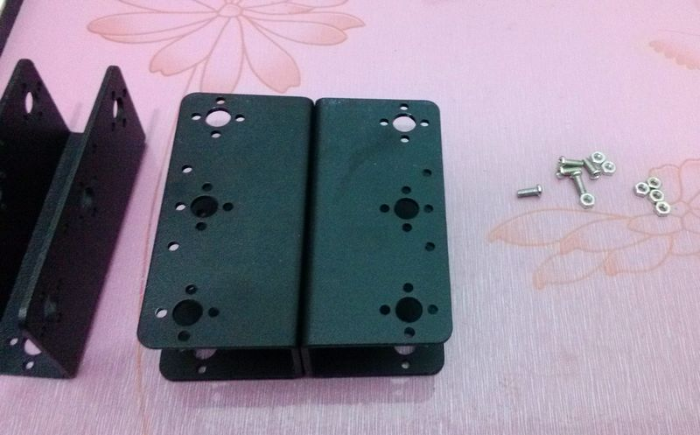

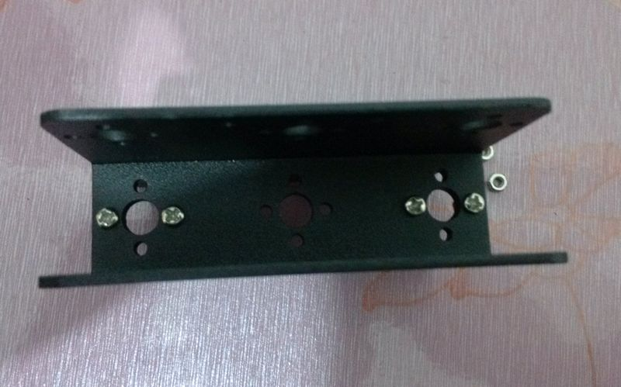

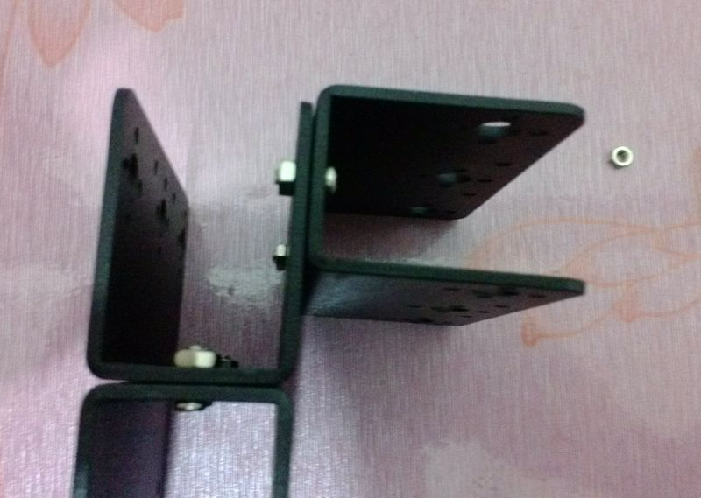

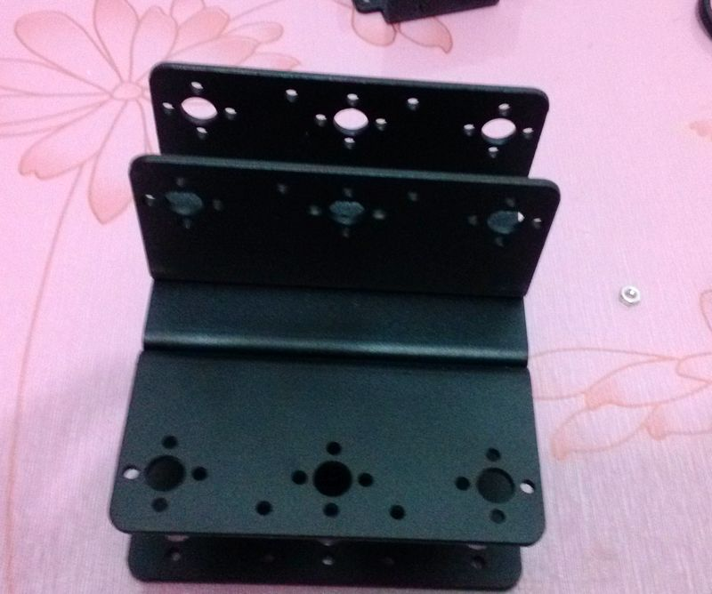

4, install the bottom rudder support: first good bearings and cups bearing sizes 3*8*4. Each actuator joints, side shall be equipped with an activity bearing.

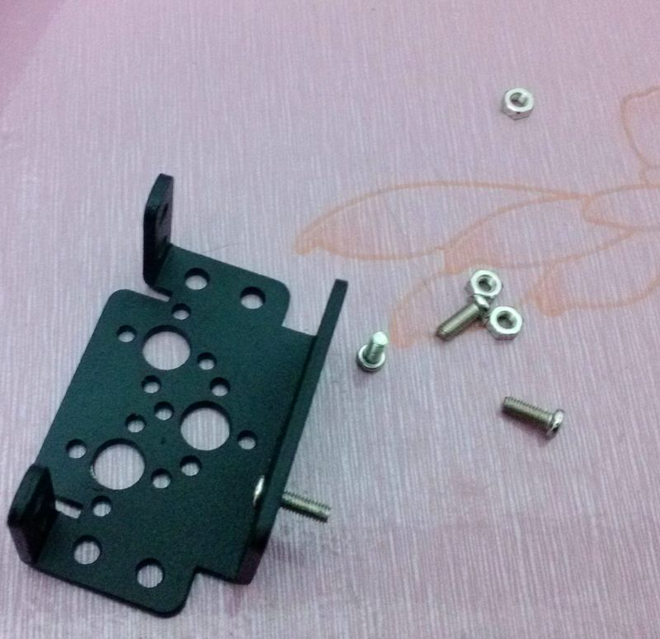

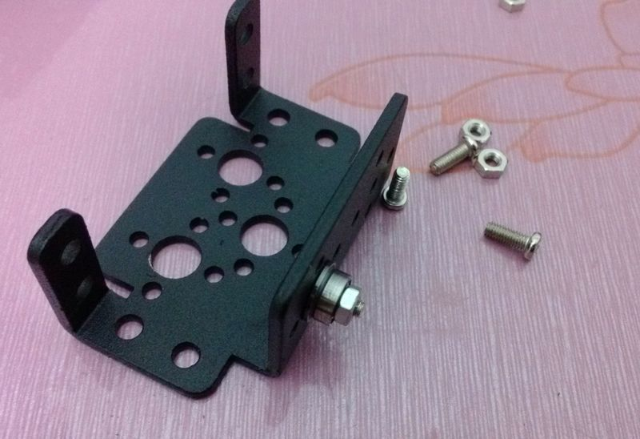
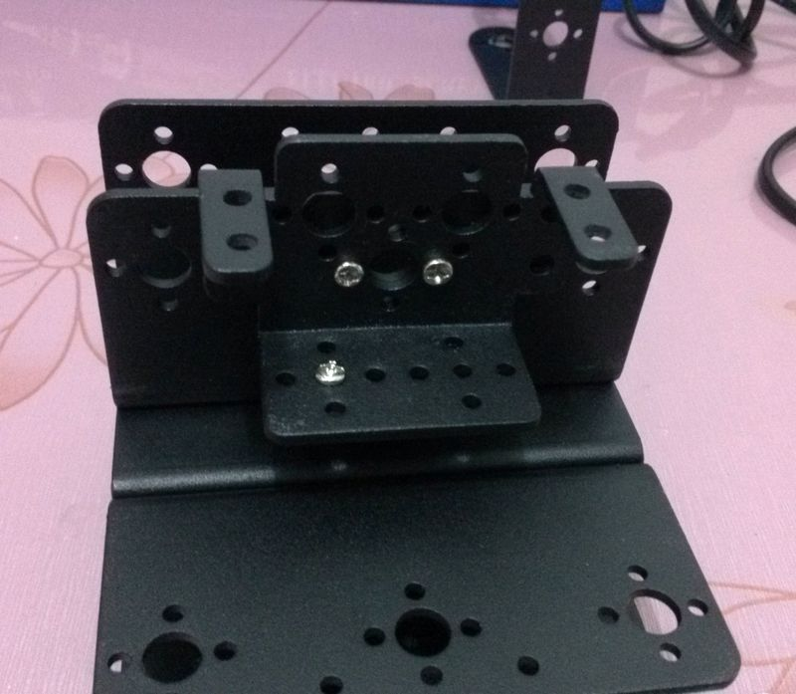
5, installed after the steering gear bracket at the bottom, begin to install the servos, prior to installing the servos in mind: to adjust the rudder angle, joint activities in the context of effectively you need. We use the rudder's angle rocker arm accessories to have a rough estimate, around manually to a corner, and then select the median point of the installation.

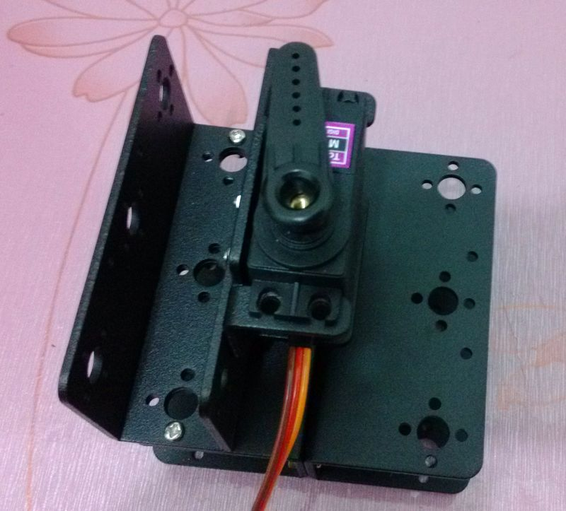
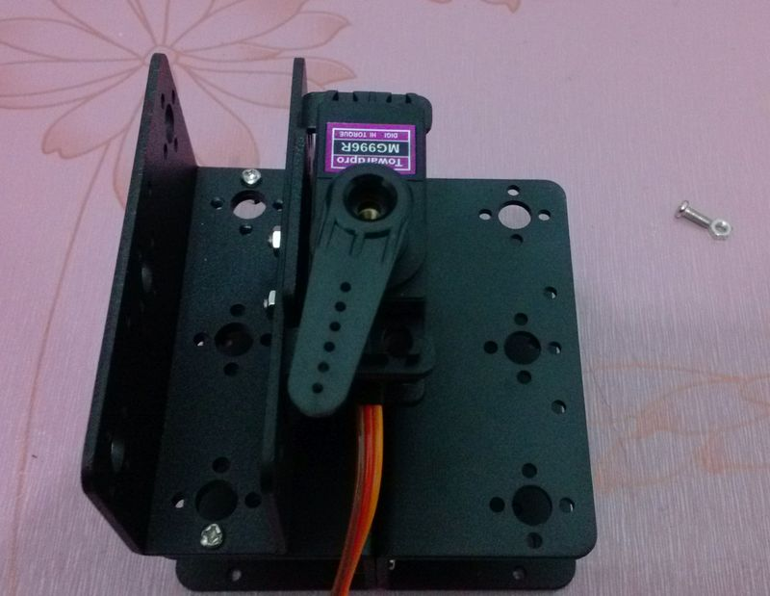

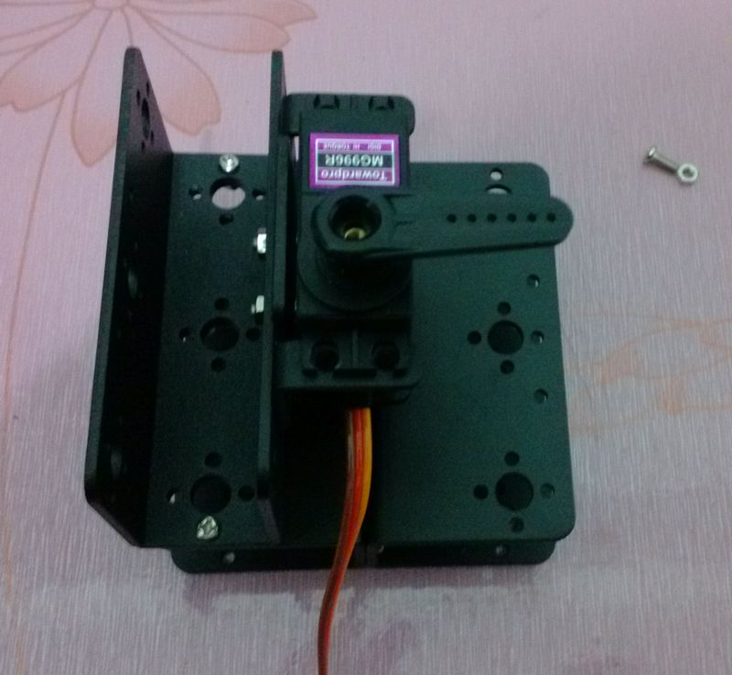

Estimate angles is complete, replace metal wheel, keeping perspective. Note the metal wheel diameter.

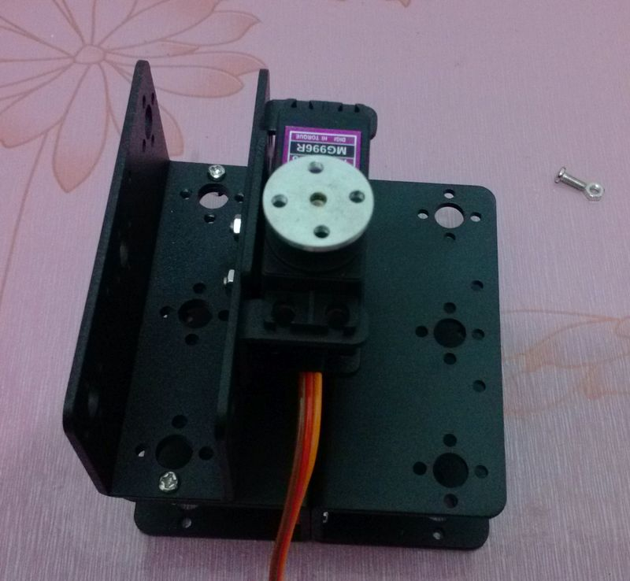

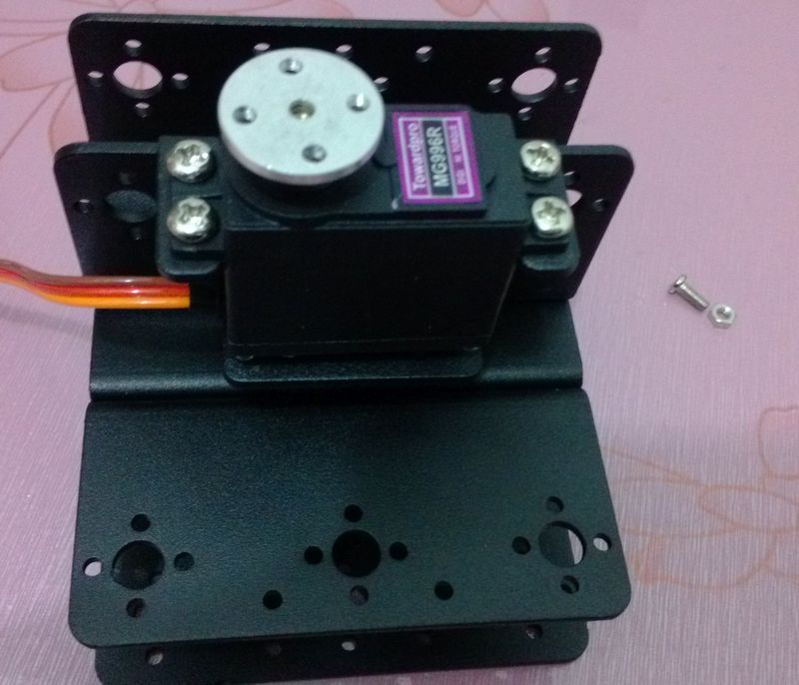

Long U -shaped bracket installed on the bottom of the rudder, and notice to overlay a steering gear bracket, extends for 2 -DOF joints.

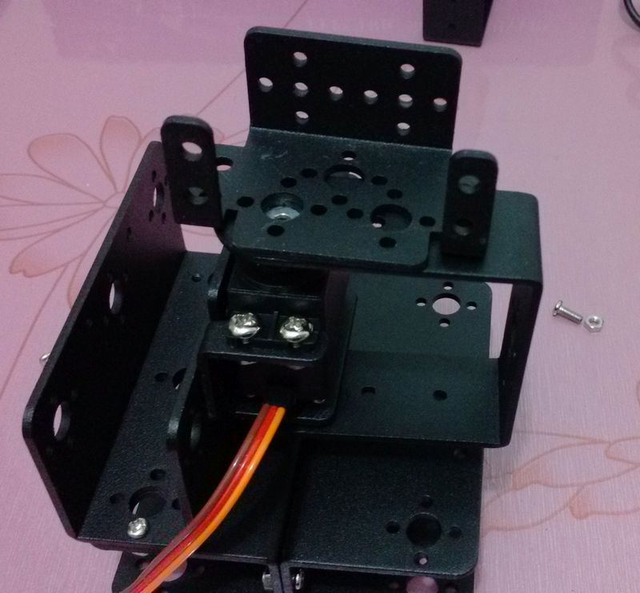

Front:

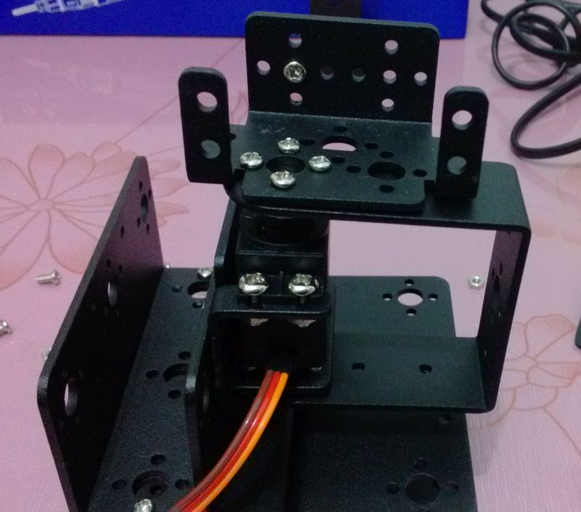

Opposite: each activity you want to install a steering gear bracket note the side bearings.

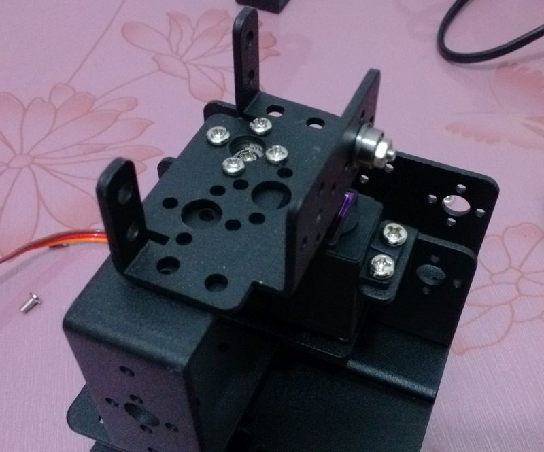

6, we used the same methods: adjust the angle of the rudder in place, then install u .

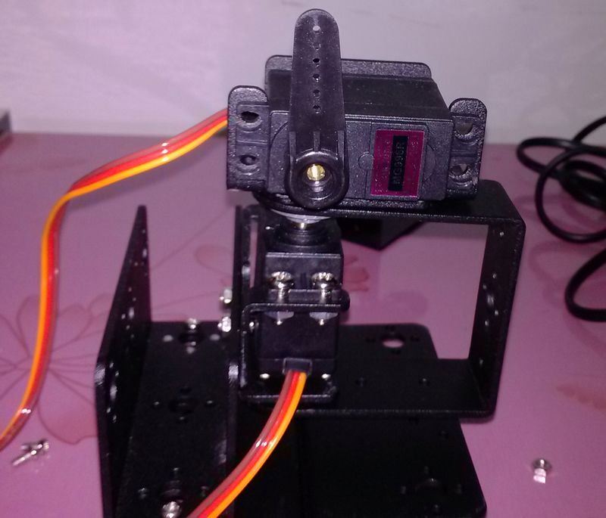

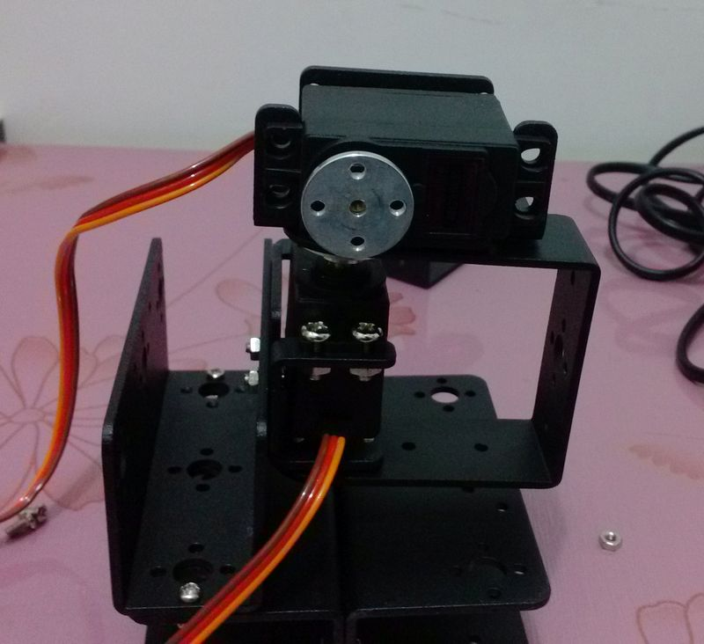

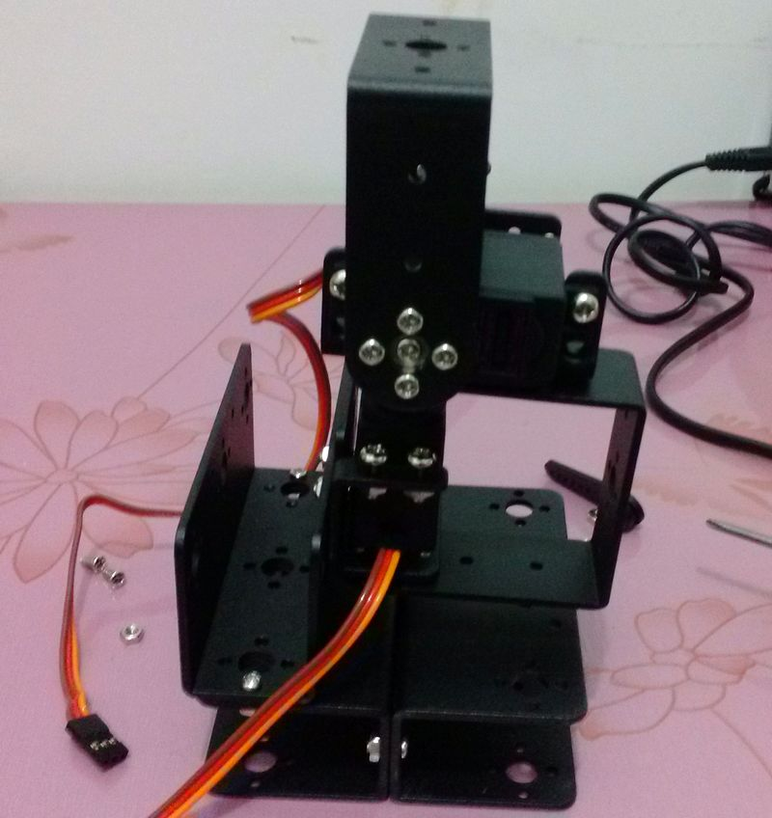

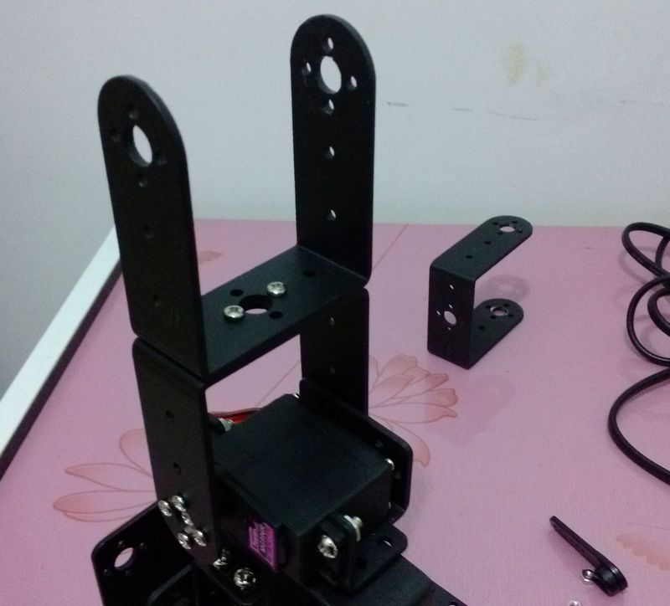

7combination, below, install the next part: need steering gear bracket and l components.
7combination, below, install the next part: need steering gear bracket and l components.

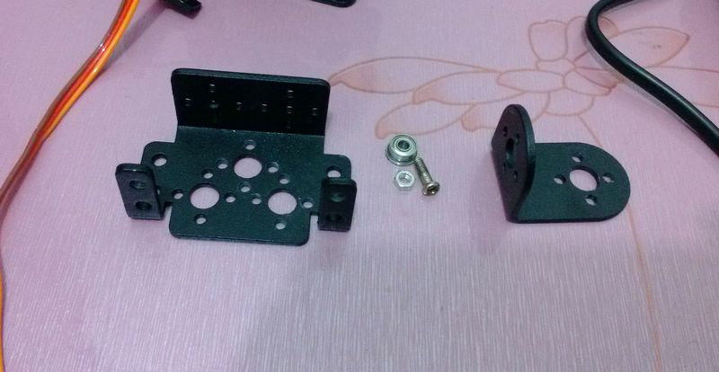

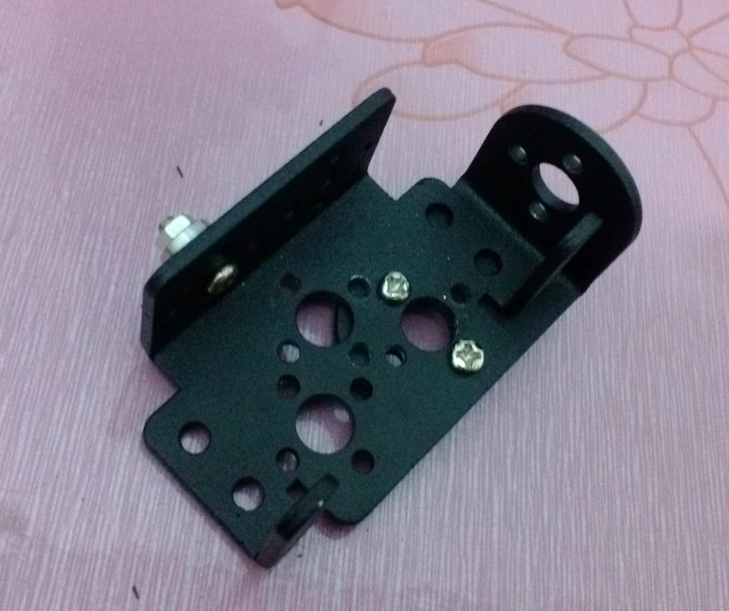

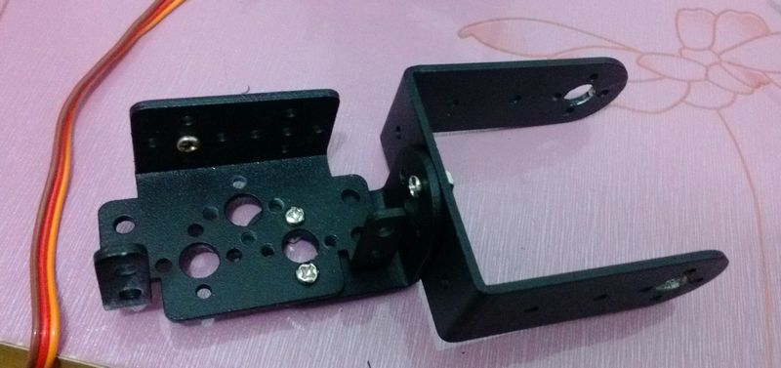

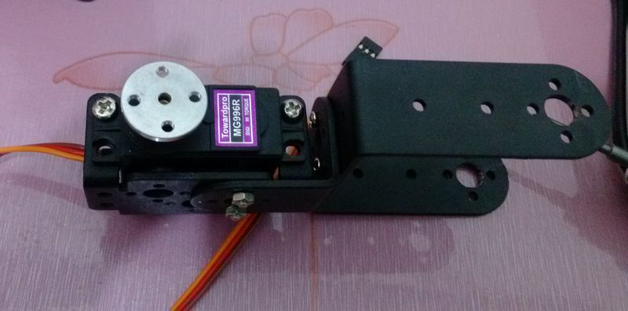
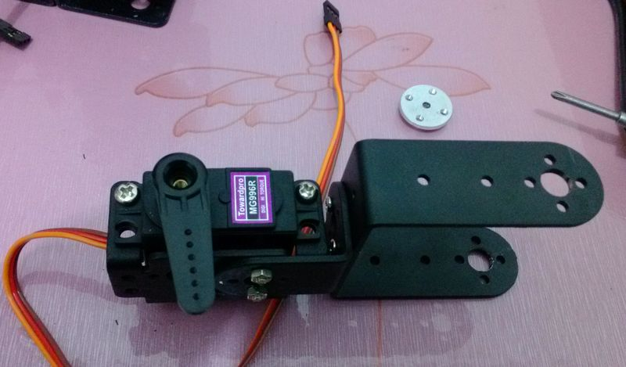

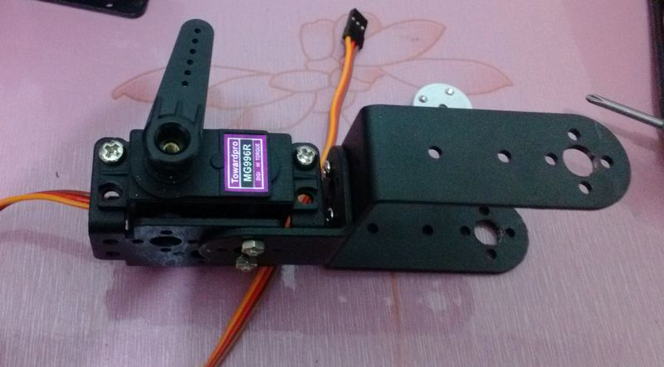
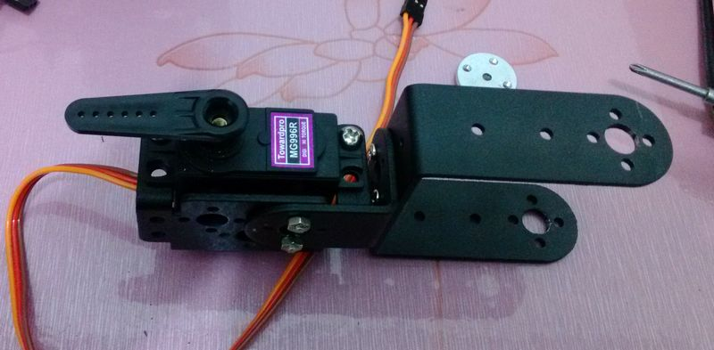

The earlier part is inserted on a previously installed location, just coupled together.

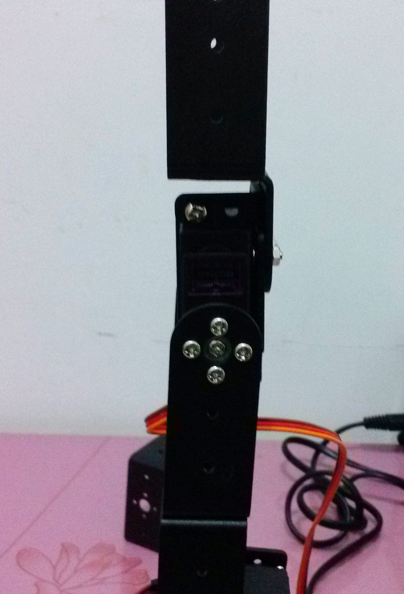

8, began installing robots head: two steering gear bracket together.
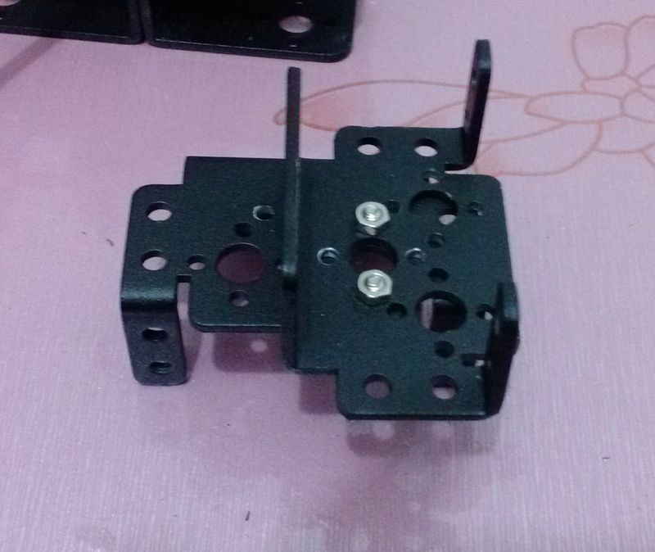
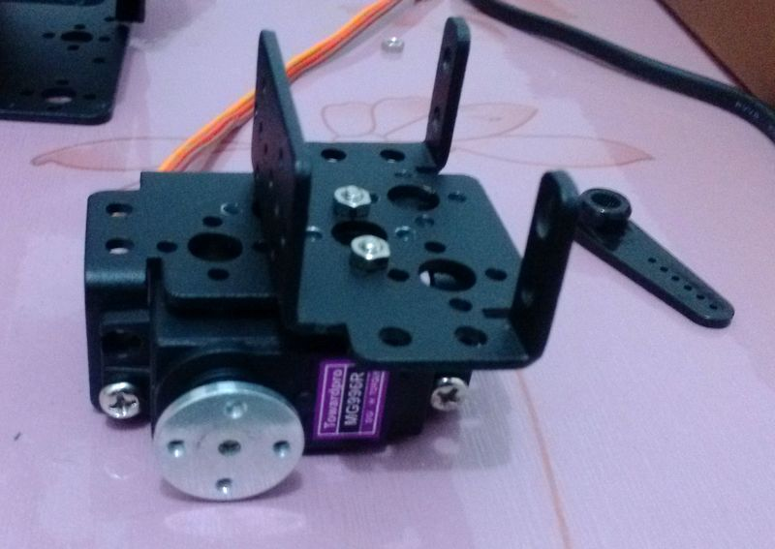

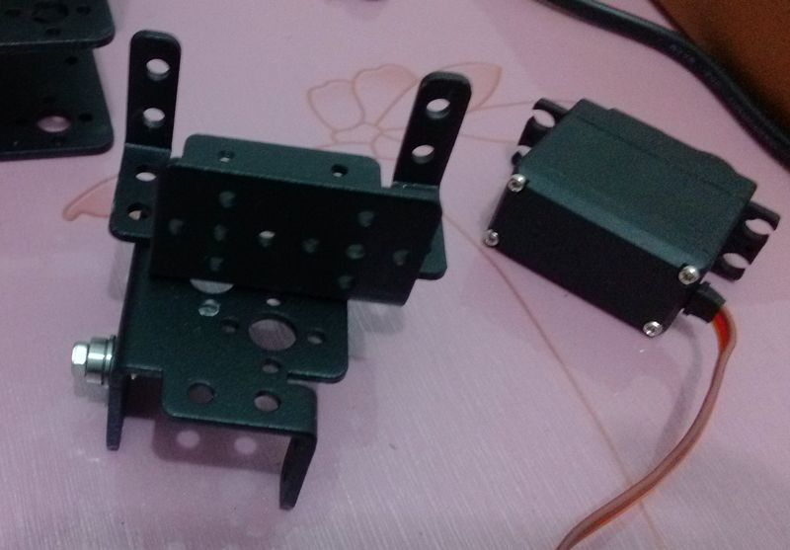
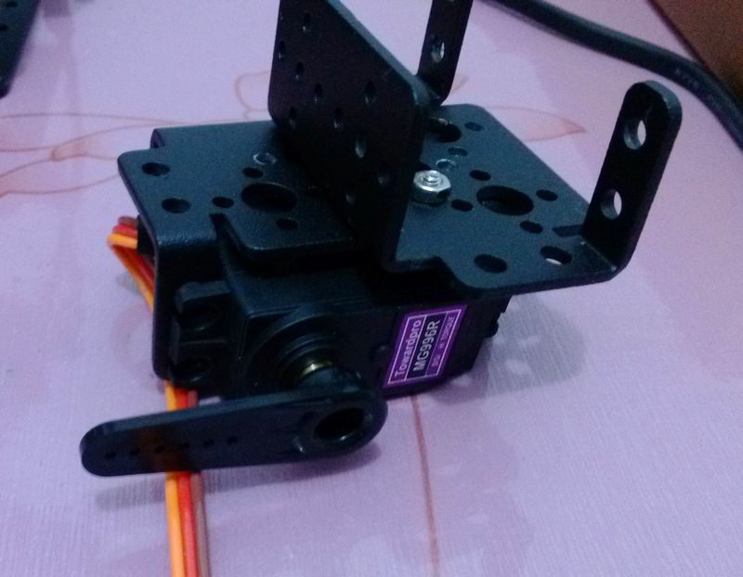
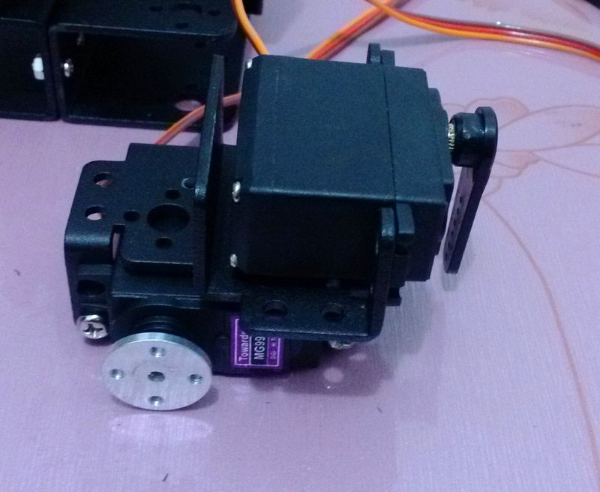
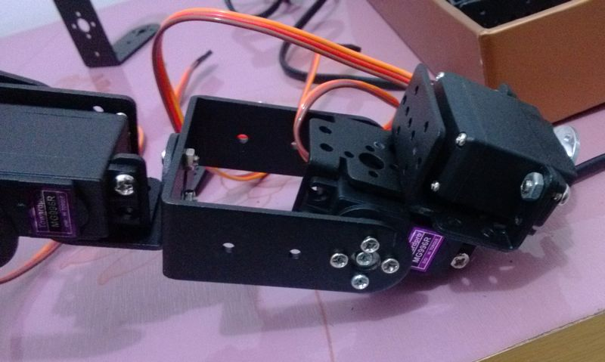

9, installation of hand: hand needs a metal wheel tie.


